# Red Team vs. Blue Team: Inside the Cyber Fortress

Cybersecurity, Penetration Testing, Incident Response, Collaboration, Risk Mitigation

August 17, 2023

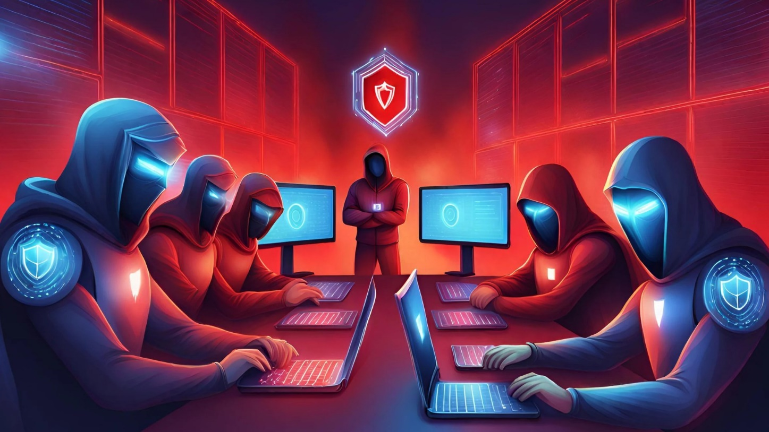

In the realm of cybersecurity, the dynamic and ever-evolving landscape of threats necessitates a proactive approach to safeguarding digital assets. This is where the roles of Red Team and Blue Team come into play. Red Team and Blue Team represent two sides of the same coin—Penetration Testing and Incident Response. In this blog post, we will explore the crucial aspects of both teams, their objectives, methodologies, and how they collaborate to enhance an organization's overall security posture.

## The Red Team - Unleashing Threats in a Controlled Environment

The Red Team plays a pivotal role in the realm of cybersecurity, consisting of ethical hackers adept at mimicking real-world adversaries. This team undertakes the critical task of simulating cyber-attacks on an organization's systems and infrastructure. Their ultimate objective is to unearth vulnerabilities and weaknesses that could potentially be exploited by malicious actors. Employing a diverse arsenal of techniques, from phishing attacks to sophisticated hacking maneuvers, Red Team exercises are meticulously crafted to mirror genuine threats that organizations may face.

These simulated cyber challenges serve as a litmus test for an organization's defensive capabilities. By subjecting the infrastructure to these carefully orchestrated attacks, Red Team assessments offer a profound understanding of the efficacy of existing security measures. Through this process, organizations gain the ability to identify potential blind spots, strengthen their incident response strategies, and fortify their digital defenses. The Red Team's contributions extend beyond uncovering weaknesses; they empower organizations to proactively enhance their security posture, making them more resilient in the face of emerging threats.

## Penetration Testing - The Art of Ethical Intrusion

At the heart of Red Team operations lies the art of penetration testing; an indispensable element in the arsenal against cyber threats. This process, an intricate facet of the Red Team's endeavors, revolves around a systematic and methodical exploration of an organization's digital ecosystem. With a keen eye for security shortcomings, penetration testers embark on a mission to unveil vulnerabilities that could potentially expose the organization to risk.

This multifaceted approach is a dynamic amalgamation of automated tools and hands-on techniques, meticulously executed to unearth weaknesses within the network, applications, and devices. By subjecting the organization's digital assets to this rigorous examination, penetration testing not only uncovers hidden vulnerabilities but also equips organizations with the insights required to fortify their defenses. This proactive stance enables organizations to bridge security gaps, preempt potential attackers, and bolster their resilience against evolving cyber threats. The systematic nature of penetration testing not only serves as a preemptive strike against potential vulnerabilities but also solidifies the foundation upon which the organization's security architecture stands.

## The Blue Team - Defending the Fortress

In the intricate dance of cybersecurity, the Blue Team emerges as the stalwart guardians of the digital realm. As the Red Team assumes the guise of potential adversaries, the Blue Team takes center stage as the organization's shield-bearers. This team, consisting of adept cybersecurity professionals, shoulders the vital responsibility of constant vigilance, detection, and responsive action in the face of looming cyber threats.

The Blue Team's mission is firmly rooted in the principles of fortitude and adaptability. Their watchful eyes and strategic approach ensure the organization's ongoing cyber resilience. When the inevitable occurs and a cyber breach transpires, the Blue Team orchestrates its incident response strategy with precision. Swift action is imperative, as the Blue Team endeavors to contain the breach, investigate its origins, and mitigate the damage. By doing so, they play a pivotal role in minimizing the impact of successful cyber-attacks, steering the organization back on track while amassing invaluable insights for future defense enhancements. In a realm where agility and readiness are paramount, the Blue Team stands as a bastion against digital incursions, upholding the organization's reputation, customer trust, and operational integrity.

## Incident Response - A Battle Plan for Cyber Emergencies

Battle-tested Incident Response (IR) plans stand essential for the fortress against the ever-looming specter of cyber emergencies. When the digital ramparts are breached and security is compromised, it is the Blue Team's moment to shine. Armed with a meticulously crafted IR plan, the Blue Team transforms into a well-coordinated force, ready to tackle the most formidable cyber challenges.

The IR plan serves as the blueprint for navigating the tumultuous waters of a security breach. It's a comprehensive document, outlining a step-by-step strategy that spans from the initial breach detection to the full restoration of normalcy. Each phase of the plan plays a distinct role. The containment phase focuses on isolating the breach to prevent further spread, while the investigation phase involves dissecting the incident to understand its scope, origin, and potential impact. Once these initial phases are addressed, the remediation phase takes center stage, involving the implementation of countermeasures to eradicate the threat and restore affected systems.

The Incident Response team's role is of paramount significance throughout this process. Their swift and well-coordinated actions not only minimize the damages inflicted by the breach but also play a pivotal role in preserving critical evidence. This evidence not only aids in understanding the breach but can also prove crucial for subsequent legal actions, should they be necessary. As the digital landscape continues to evolve, a robust and agile Incident Response plan becomes a strategic asset, serving as a beacon of stability in times of chaos, ensuring that the organization emerges stronger and more resilient from the crucible of cyber adversity.

## Collaboration - Forging a Stronger Defense

A harmonious alliance emerges between the Red Team and the Blue Team; a partnership that transcends rivalry, to weave a stronger fabric of defense for organizations. This dynamic interplay signifies a mutual symbiosis with the singular purpose of elevating an organization's security posture to new heights. Rather than a contest, it's a strategic collaboration where each team plays an indispensable role.

The Red Team's penetration testing endeavors serve as an invaluable beacon illuminating the path to fortified defenses. Their simulated attacks unearth vulnerabilities, which, when addressed, serve as fortified ramparts against real-world breaches. By offering an outsider's perspective and emulating adversary tactics, the Red Team provides a fresh lens through which the Blue Team can refine their strategies. The insights harvested from these simulated attacks are like precious gems, glistening with the potential to uncover hidden flaws and blind spots within an organization's security infrastructure.

On the other side of this partnership, the Blue Team stands poised to translate these insights into actions. They leverage the intelligence from Red Team exercises to refine their detection mechanisms, enhancing their ability to swiftly identify and respond to emerging threats. The Blue Team's proactive efforts focus on fortifying the organization's weak points and continuously refining their defensive mechanisms. This iterative dance of learning and adaptation becomes the cornerstone of an organization's security architecture, ensuring that the knowledge gained from simulated attacks is embedded in the very DNA of its defenses.

The collaboration between the Red Team and the Blue Team is a continuous journey, an ongoing dialogue that perpetuates growth and resilience. By embracing this symbiotic relationship, organizations transcend the limitations of isolated perspectives, emerging with a security infrastructure that's agile, fortified, and prepared to weather the ever-shifting tides of cyber threats.

## Reflecting

The collaboration between the Red Team and the Blue Team emerges as a strategic alliance designed to fortify an organization's digital stronghold. The Red Team, a congregation of ethical hackers, takes on the mantle of adversaries, simulating cyber threats to reveal vulnerabilities lurking in an organization's systems. Their simulations mirror real-world attacks, including phishing, social engineering, and advanced hacking techniques, empowering organizations with insights that shape a more robust security landscape.

Concurrently, the Blue Team, a collective of skilled cybersecurity professionals, stands as the organization's defenders. Charged with the responsibility of constant surveillance, detection, and responsive action, the Blue Team pivots into action when a security breach occurs. Guided by a meticulously constructed Incident Response (IR) plan, they contain, investigate, and remediate the breach. Through this orchestrated effort, damages are minimized, normal operations are restored, and vital evidence is preserved for analysis and future prevention.

The synergy between the Red Team's proactive penetration testing and the Blue Team's vigilant defense fosters a cycle of continuous improvement. Penetration testing informs and refines security measures, strengthening the organization's preemptive defenses. The Blue Team harnesses insights from Red Team exercises to fine-tune detection mechanisms and optimize responses. This collaborative approach cements a resilient security infrastructure, perpetually evolving and adapting to an ever-changing threat landscape.

As the digital realm becomes increasingly intricate, the Red Team and Blue Team showcase how a cooperative mindset bolsters an organization's cyber fortitude. The interplay of simulated threats and expert defense transcends competition, enabling organizations to not only withstand cyber onslaughts but thrive in the face of adversity. In this collaborative journey, the Red Team and Blue Team exemplify the fusion of art and science that underpins the protection of digital assets—the cornerstone of modern security in an interconnected world.

# Resources:

* [[Click Here]](https://www.crowdstrike.com/cybersecurity-101/red-team-vs-blue-team/) *CrowdStrike: RED TEAM VS BLUE TEAM IN CYBERSECURITY (2023)*
* [[Click Here]](https://purplesec.us/red-team-vs-blue-team-cyber-security/) *PurpleSec: Red Team VS Blue Team: What’s The Difference?*
* [[Click Here]](https://www.coresecurity.com/blog/best-practices-red-teams-blue-teams-purple-teams) *Core Security: Best Practices for Red Teams, Blue Teams, Purple Teams*
* [[Click Here]](https://www.knowledgehut.com/blog/security/red-team-vs-blue-team) *KnowledgeHut: Red Team vs Blue Team in Cyber Security: Check Differences (2023)*
* [[Click Here]](https://www.threatintelligence.com/blog/red-team-vs-blue-team) *Threat Intelligence: How Red and Blue Teams Work Together in Cybersecurity (2023)*
* [[Click Here]](https://www.splunk.com/en_us/blog/learn/red-team-vs-blue-team.html) *Splunk: Red Teams vs. Blue Teams - What’s The Difference? (2023)*
* [[Click Here]](https://nvlpubs.nist.gov/nistpubs/ir/2012/NIST.IR.7622.pdf) *NIST (NISTIR 7622): Notional Supply Chain Risk Management Practices for Federal Information Systems*
* [[Click Here]](https://www.coursera.org/articles/red-team-vs-blue-team) *Coursera: Red Team vs. Blue Team in Cybersecurity (2023)*
* [[Click Here]](https://danielmiessler.com/p/red-blue-purple-teams/) *Daniel Miessler: The Difference Between Red, Blue, and Purple Teams*
* [[Click Here]](https://www.emagined.com/red-team-and-blue-team) *Emagined Security: Red Team vs Blue Team Penetration Testing*
* [[Click Here](https://darknetdiaries.com/episode/36/) *Darknet Diaries: Episode 36 - Jeremy from Marketing (2019)*